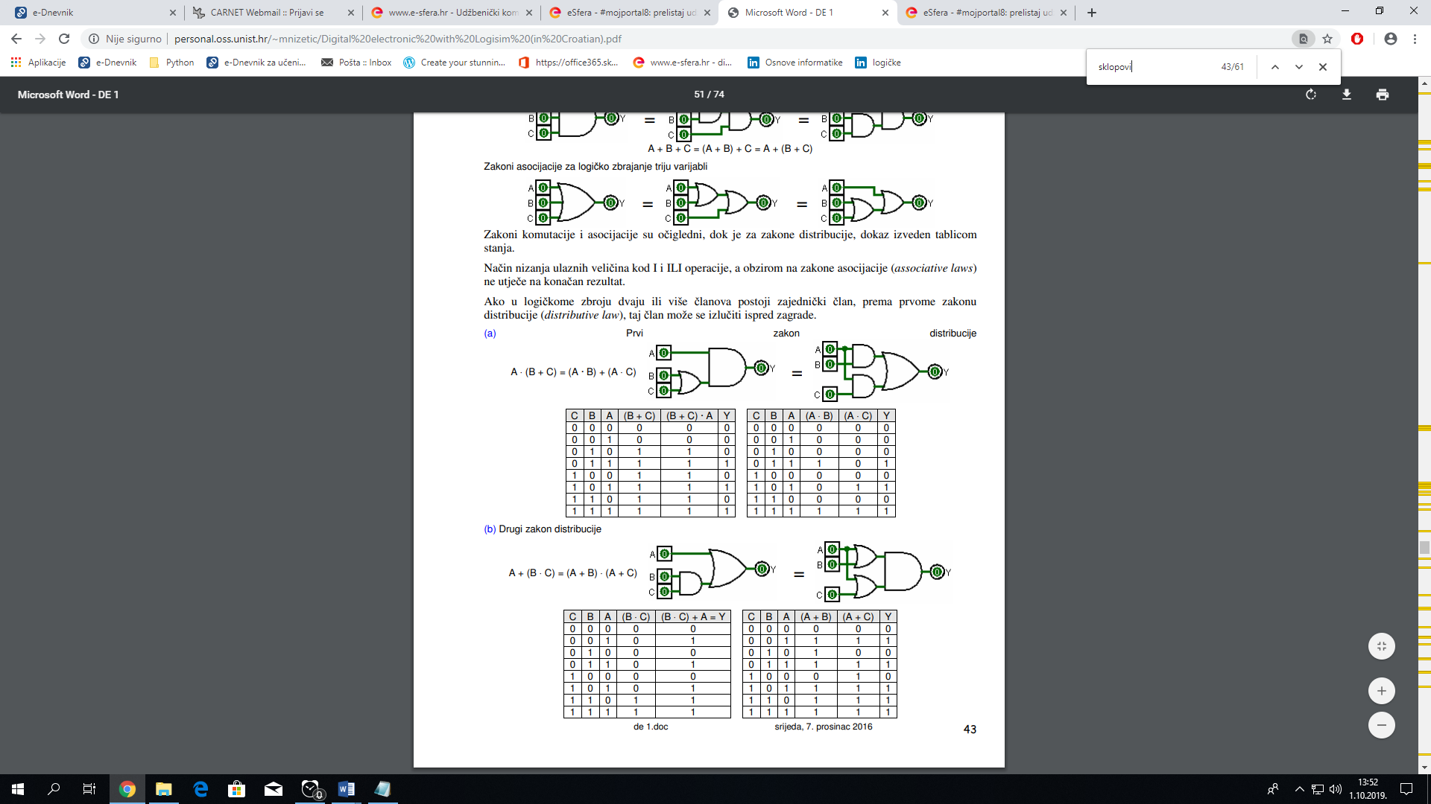

|  |  |  |  |  |  |  |
| --- | --- | --- | --- | --- | --- | --- |
| A | B | C |  |  |  | y |
| 0 | 0 | 0 |  |  |  |  |
| 0 | 0 | 1 |  |  |  |  |
| 0 | 1 | 0 |  |  |  |  |
| 0 | 1 | 1 |  |  |  |  |
| 1 | 0 | 0 |  |  |  |  |
| 1 | 0 | 1 |  |  |  |  |
| 1 | 1 | 0 |  |  |  |  |
| 1 | 1 | 1 |  |  |  |  |